**1)Create web pages using Basic HTML Tags, Table, List, Image, and Frame Tags**

**HTML Tags:**

**Character formatting:**

<html>

<head>

<title>Character tags</title>

</head>

<body bgcolor="pink">

<b>bold face</b><br><br>

<i>italic tag</i><br><br>

<u>underline tag</u><br><br>

<big>Big tag</big><br><br>

<small>Small tag</small><br><br>

<strong>Strong tag</strong><br><br>

<sub>Qualification</sub><br><br>

<sup>x 2</sup><br><br>

</body>

</html>

Output:

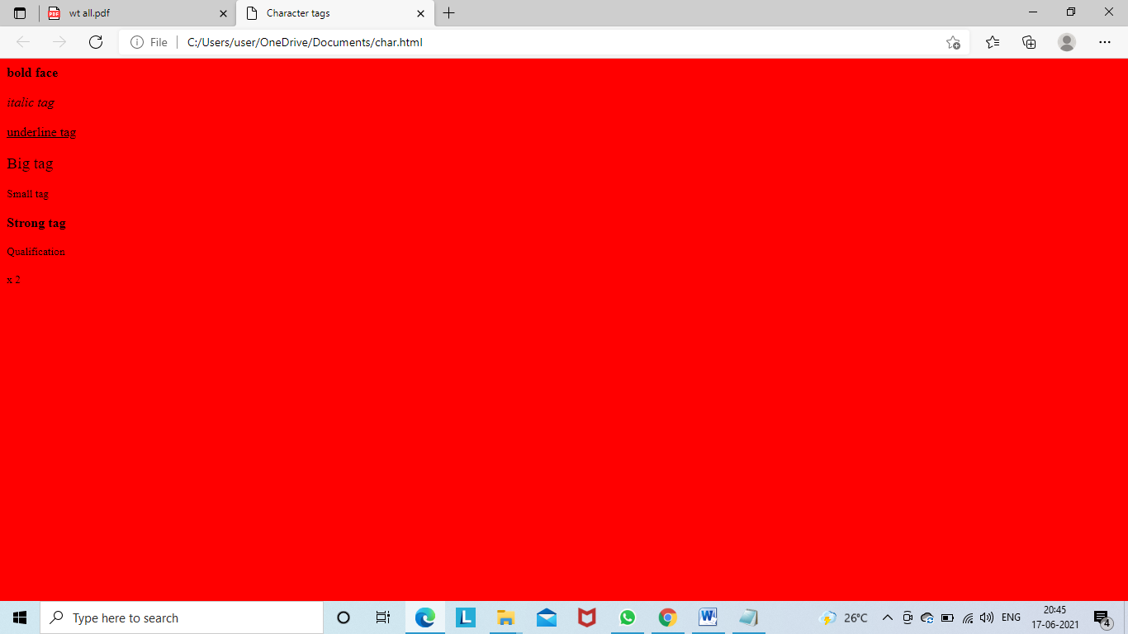

**Block formatting:**

<html>

<head>

<title>Bold Formatting</title>

</head>

<body bgcolor="pink"><br>

<p align="center">This is formatting</p>

<h1 align="left">This is h1</h1>

<h2 align="right">This is h2</h2>

<h3 align="center">This is h3</h3>

<h4>This is h4</h4>

<h5>This is h5</h5>

<h6 align="left">This is h6</h6>

<p>this is hr</p>

<hr align="center" size="10"/>

<basefont size="50">this is web</basefont>

<tt>harsha sri</tt><br>

<PRE>this is aditya</PRE>

<marquee align="right">hii kandru</marquee>

<font face="Blackadder ITC" size="20" color="Green">This is wt lab</font>

</body>

</html>

**Output:**

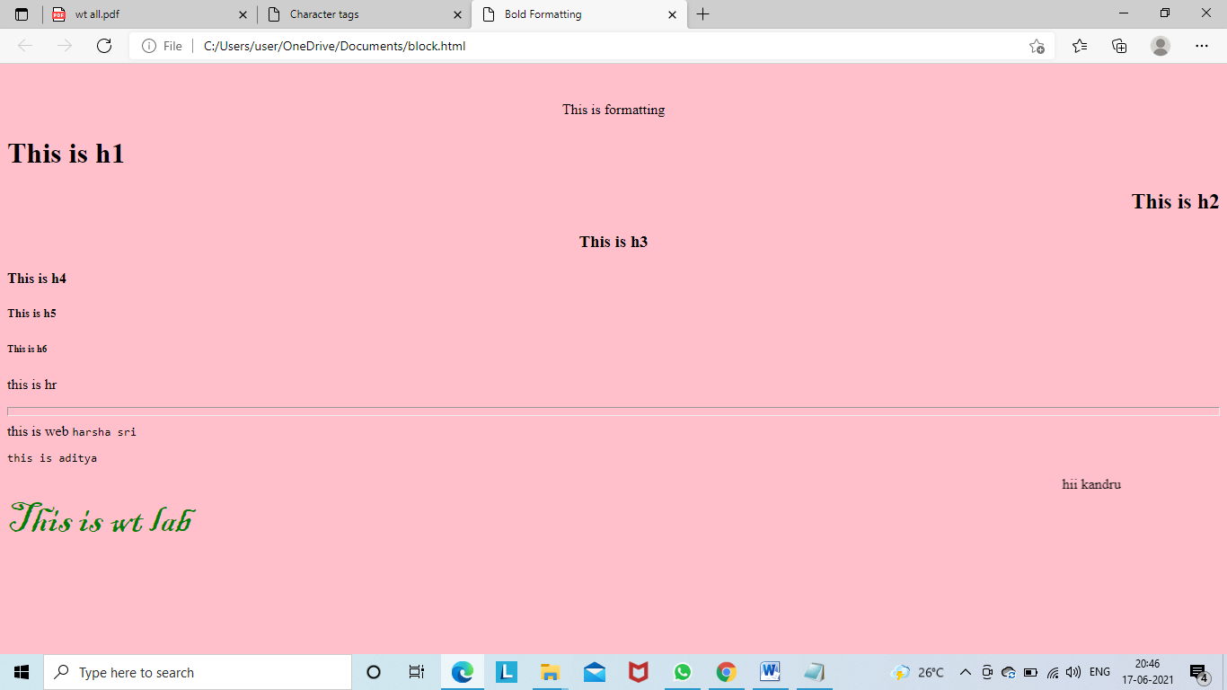

**Lists:**

**Ordered list**:

<html>

<head>

<title>Ordered lists</title>

</head>

<body>

<h4>Microsoft packages</h4>

<ol type="1">

<li>Wordpad

<li>PowerPoint

<li>Ms-Excel

</ol>

<h4>Lists</h4>

<ol type="A" start=25>

<li>ordered list

<li>unordered list

<li>nested list

</ol>

<h4>Scripting language</h4>

<ol type="I" start=4>

<li>java Script

<li>jscript

</ol>

<h4>Database application</h4>

<ol type="i" start=5>

<li>SQL

<li>Mysql

<li>Oracel

</ol>

</body>

</html>

**Output:**

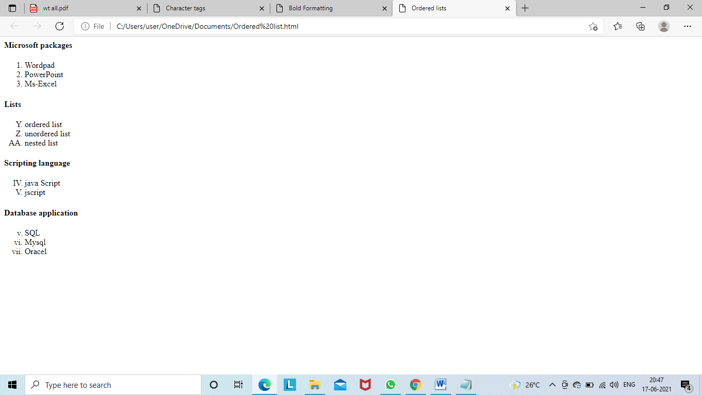

**Unordered List:**

<html>

<head>

<title>UnOrdered lists</title>

</head>

<body>

<h4>Microsoft packages</h4>

<ul>

<li>Wordpad

<li>PowerPoint

<li>Ms-Excel

</ul>

<h4>Lists</h4>

<ul type="square">

<li>ordered list

<li>unordered list

<li>nested list

</ul>

<h4>Scripting language</h4>

<ul type="disc">

<li>java Script

<li>jscript

</ul>

<h4>Database application</h4>

<ul type="circle">

<li>SQL

<li>Mysql

<li>Oracel

</ul>

</body>

</html>

**Output:**

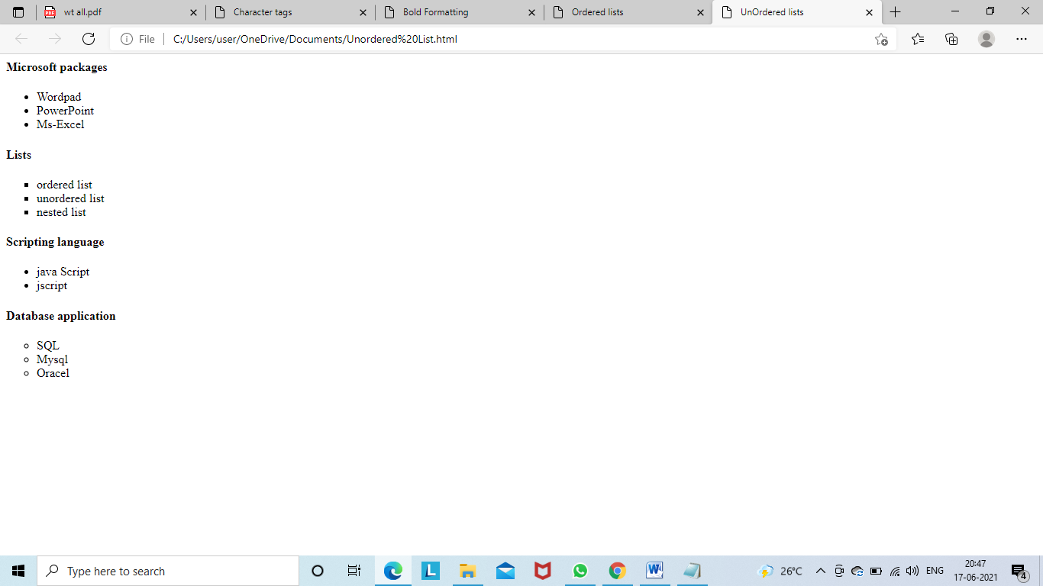

**Image:**

<html>

<head>

<title>IMAGE Tags</title>

</head>

<body>

<center>

<img src="D:scenery.jpg"height=700$,width=100%>

</center>

</body>

</html>

**OUTPUT:**

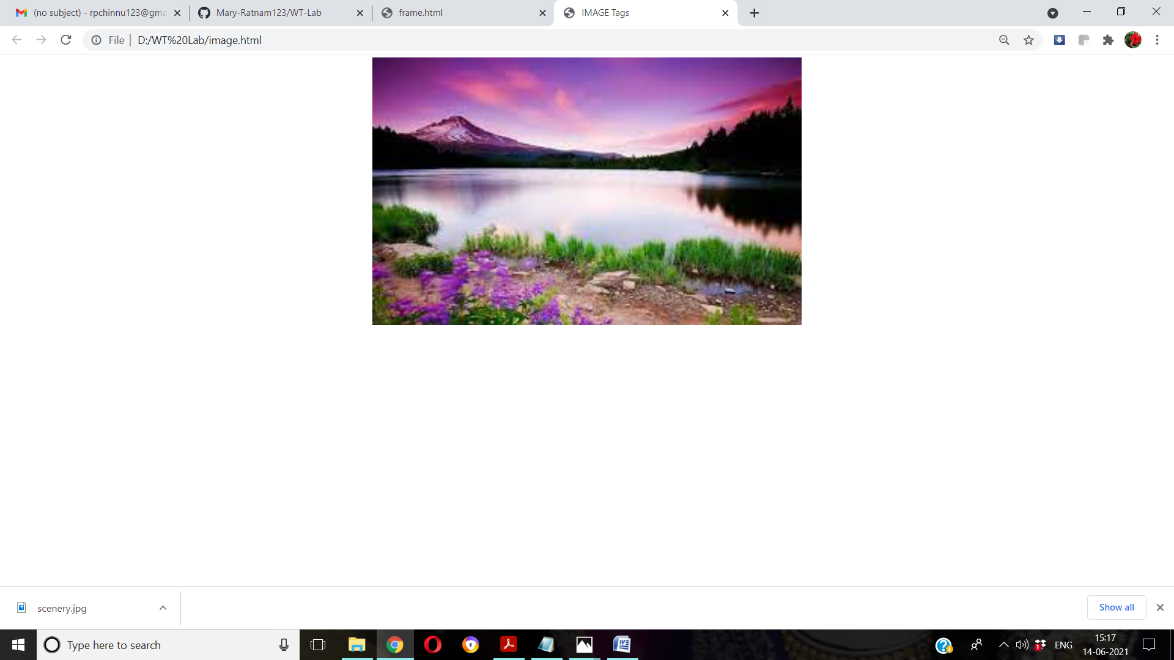

**Table:**

<html>

<head>

<title>table page</title>

</head>

<body bgcolor="pink">

<table align="left" cellpadding="2" cellspacing="2" border="3" bgcolor="cyan">

<tr>

<th colspan="4">Sample Table</th>

</tr>

<tr>

<th>HEAD1</th>

<td rowspan="3">CELL2</td>

<th>HEAD3</th>

<th>HEAD4</th>

<tr>

<td>CELL1</td>

<td>CELL3</td><td>CELL4</td>

</tr>

<tr>

<td>CELL5</td>

<td colspan="2" align="center">CELL6</td>

</tr>

</table>

</body>

</html>

Output:

Frame:

First.html

<html>

<body bgcolor="pink">

<font size=5> <p>This is first frame</p> </font>

</body>

</html>

Second.html

<html>

<body bgcolor="pink">

<font size=5> <p>This is second frame</p> </font>

</body>

</html>

Frame.html

<frameset cols="45%,55%">

<frame name="fr1" src="first.html" noresize scrolling="yes">

<frame name="fr2" src="second.html" noresize scrolling="yes">

</frameset>

**Output:**

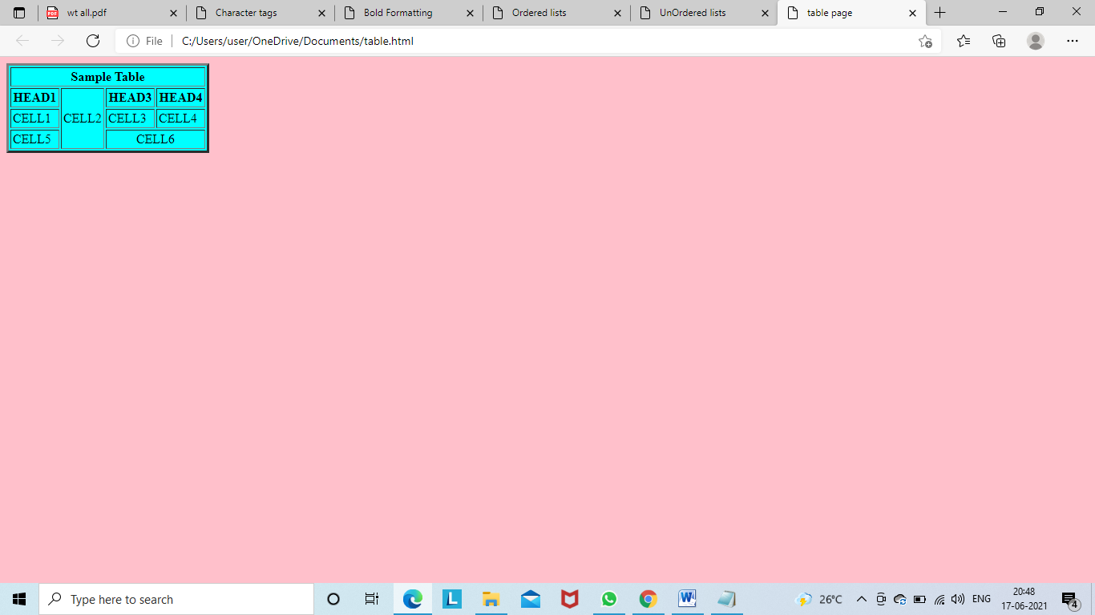

**Frame:**

**First.html**

<html>

<body bgcolor="cyan">

<font size=5> <p>This is first frame</p> </font>

</body>

</html>

**Second.html**

<html>

<body bgcolor="orange">

<font size=5> <p>This is second frame</p> </font>

</body>

</html>

**Third.html**

<html>

<body bgcolor="red">

<font size=5> <p>This is third frame</p> </font>

</body>

</html>

**Forth.html**

<html>

<body bgcolor="blue">

<font size=5> <p>This is forth frame</p> </font>

</body>

</html>

**Frame.html**

<frameset cols="40%,40%" rows="40%,40%">

<frame name="fr1" src="first.html" noresize scrolling="yes">

<frame name="fr2" src="second.html" noresize scrolling="yes">

<frame name="fr3" src="third.html" noresize scrolling="yes">

<frame name="fr4" src="forth.html" noresize scrolling="yes">

</frameset>

**OUTPUT:**

